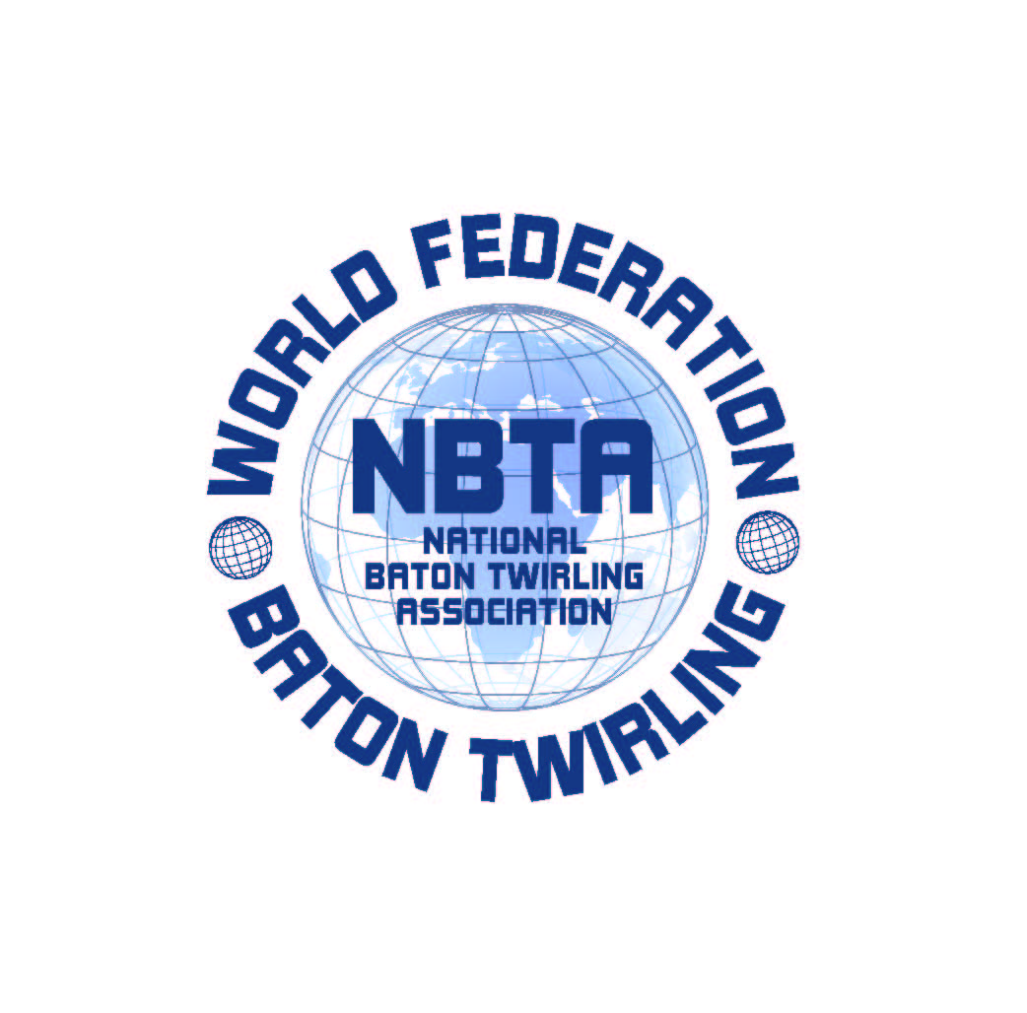

SEDE: V.le Risorgimento n°21 -26017-Trescore Cremasco (CR)
Tel.0373 / 274851 Fax 0373/291336
P. IVA 01119000196
MAIL: info@nbtaitalia.com
WEB: www.nbtaitalia.com

ASSOCIAZIONE NAZIONALE BATON TWIRLING
Dal 1983 membro della NBTA Europa e della World Federation W.F.N.B.T.A.

RESERVATION FORM
For DAILY BADGE_PASS and BRACELETS_PASS
(only for those overnight staying outside the Village Ge.Tur.)

Badge_Pass Bracelets_Pass Total
(athletes) (for all other)

October, 3rd Green _______ _________ ________

October, 4th Pink _______ _________ ________

Each badge_pass for athletes will be nominative . Please fill out the attached form with the names of the athletes who want to book for the badge_pass, one for each day.

Single fee of each badge_pass or bracelets_pass is € 20,00 per day.

To confirm the reservation, please make payment in advance by bank transfer on:
Swift Code: BAPPIT21R33
Iban Code: IT61Q 05034 57260 000000165425

Send your reservation by e.mail at info@nbtaitalia.com, attaching this completed form, athletes list and the receipt of payment bank.

RESERVATION FORM
For DAILY BADGE_PASS and BRACELETS_PASS
(only for those overnight staying outside the Village Ge.Tur.)

ATHELETS LIST FOR DAILY BADGE_PASS

DATE:_______________________________

BADGE_PASS COLOR:____________________

